SPRINT 4

|  |  |
| --- | --- |
| Date | 14 november 2022 |
| Team ID | PNT2022TMID00982 |
| Project Name | Project – Signs with Smart Connectivity for Better Road Safety |

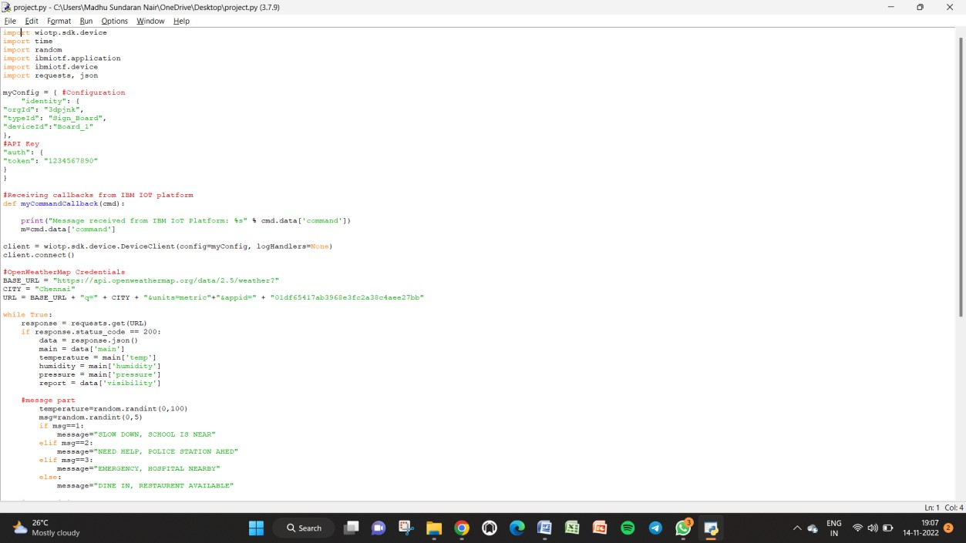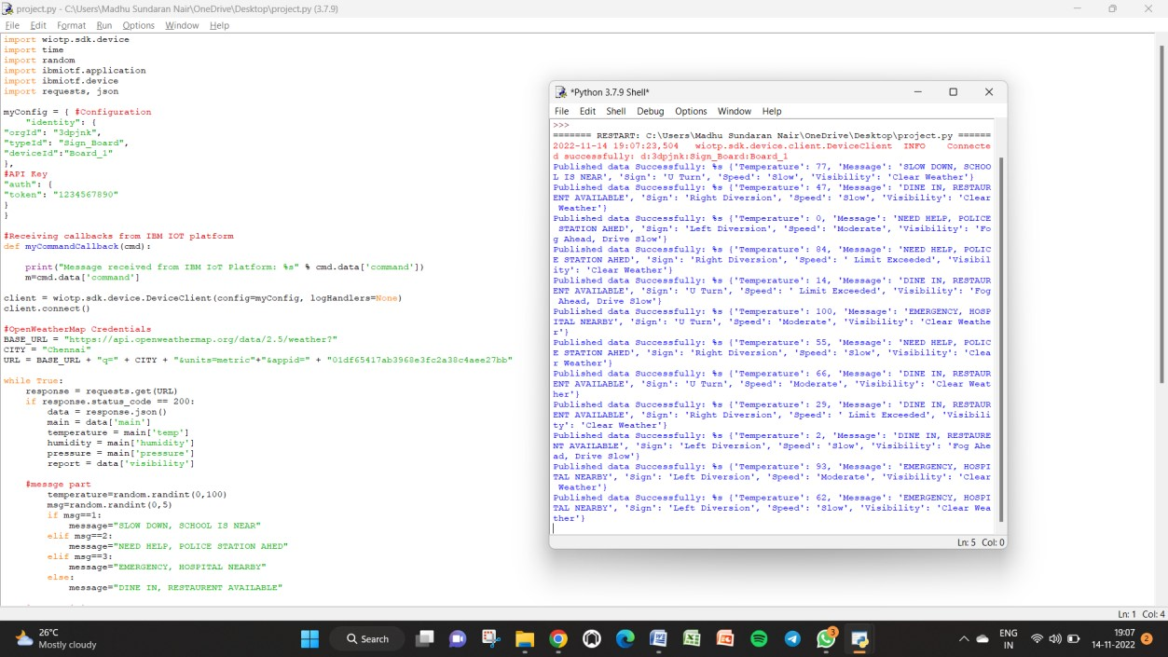

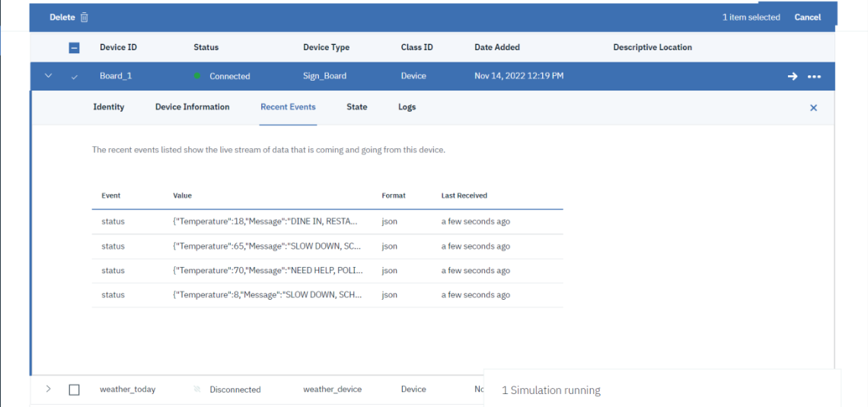

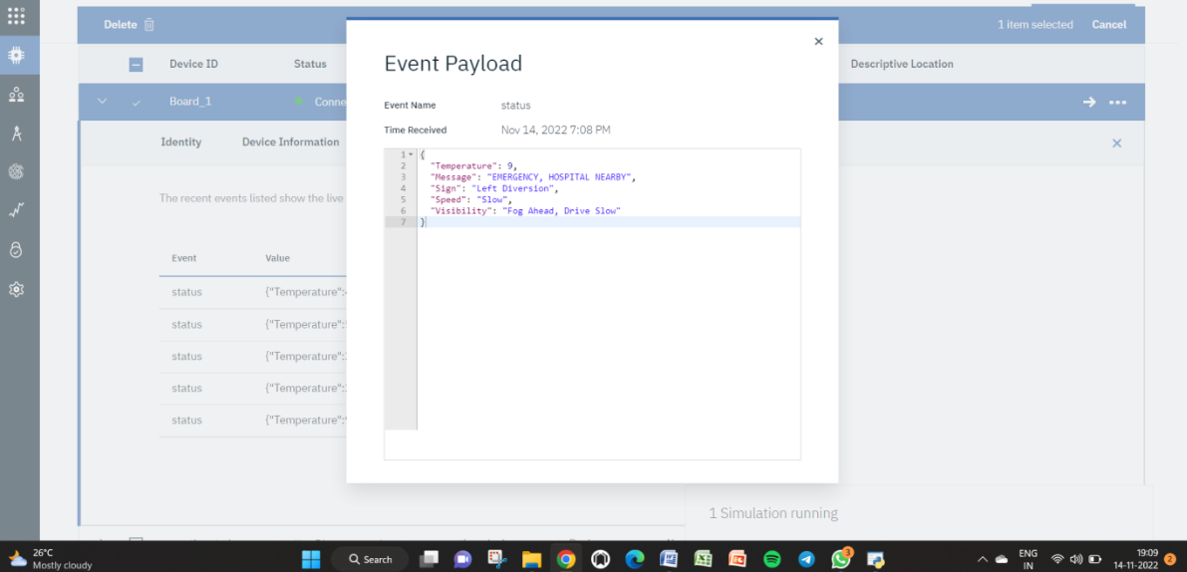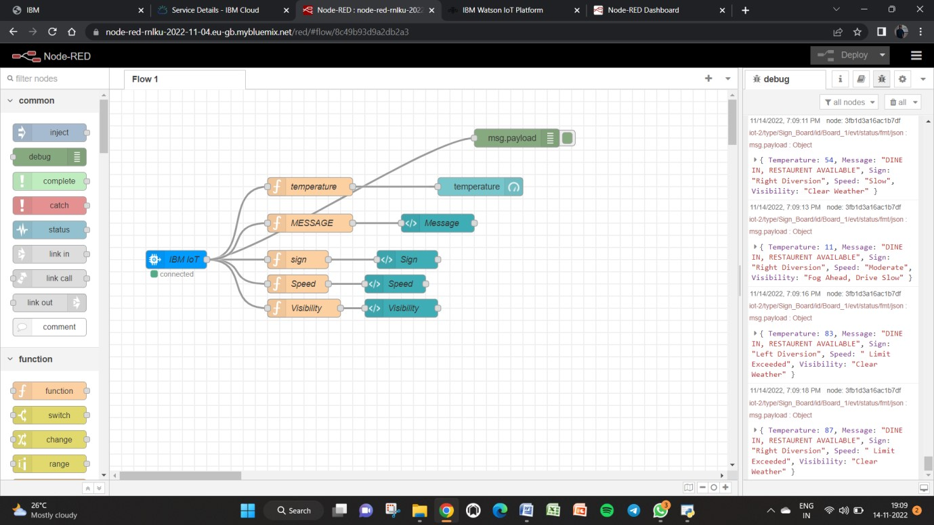

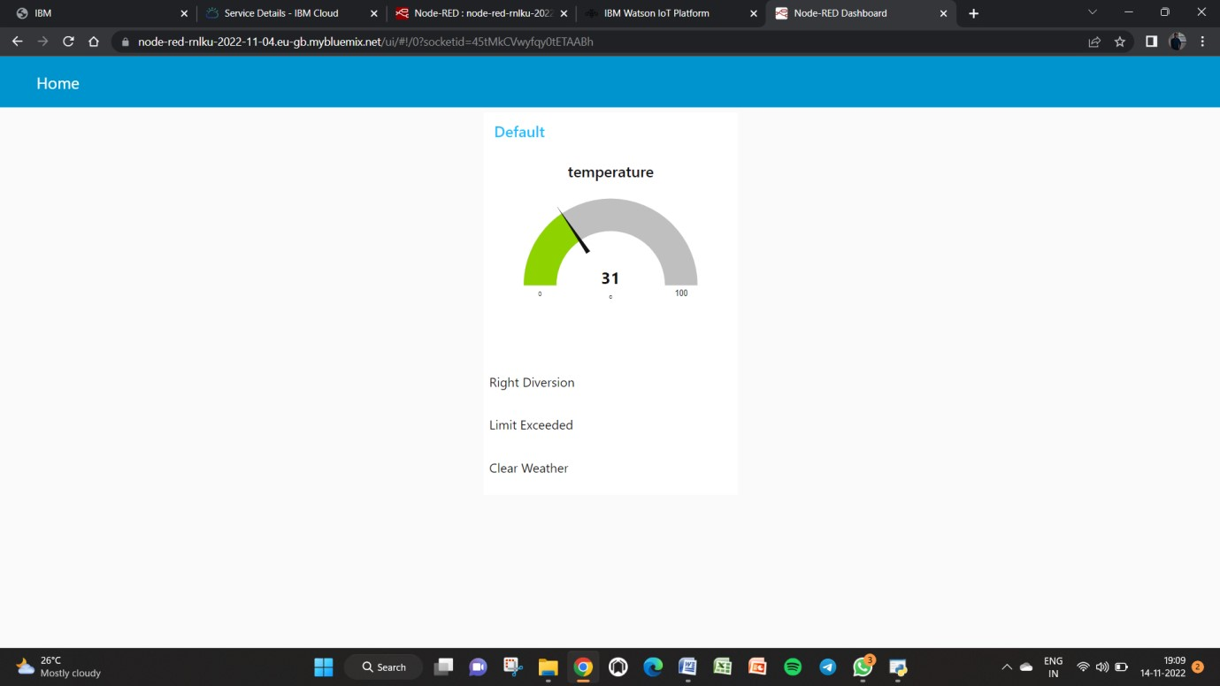

Node red : [https://node-red-rnlku-2022-11-04.eugb.mybluemix.net/ui/#!/0?socketid=45tMkCVwyfqy0tETAABh](https://node-red-rnlku-2022-11-04.eu-gb.mybluemix.net/ui/?socketid=45tMkCVwyfqy0tETAABh#!/0)